…………………………….. Academic Year
……….. Vocational and Technical Anatolian High School
9th Grades 1st Term 2nd Written Exam

Name:
Number:
Point :

- Answer the questions “about yourself ” (Kendinizle ilgili sorulmuş olan sorulara cevap veriniz.) (3 pts)
1.What’s your favourite movie? …………………………………………………………………
2.What kind of movies do you like? ………………………………………………………………..
3.Do you like horror films? ………………………………………………………………….
B)Match the movie types with the definitions.(Film çeşitlerini açıklamalarıyla eşleştiriniz) (2 pts)
Musical
Comedy
Science fiction
Romance
Western

1.This film is about future,space travel and robots. (…….)
2.Love and romance are the major topics in this film. (…….)
3.Actors and actresses sing songs during the film. (…….)
4.The characters and the topic are very comic in this film. (…….)
5.There are cowboys and horses in this film. (…….)
C)Match the free time activities with the pictures.(Boş zaman aktivitelerini resimlerle eşleştiriniz.)(2p)
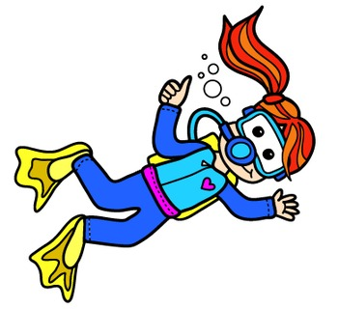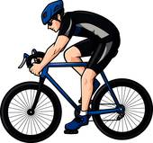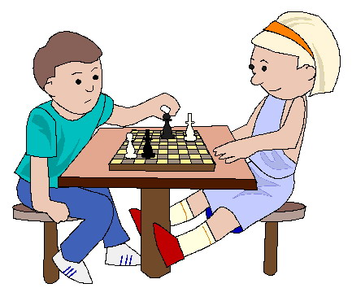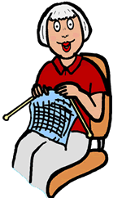

a)playing chess b)cycling c)scuba diving d)playing the guitar e)knitting f)snowboarding

D)Write the times.(Saatlerin okunuşlarını yazınız.) (2pts)
1. 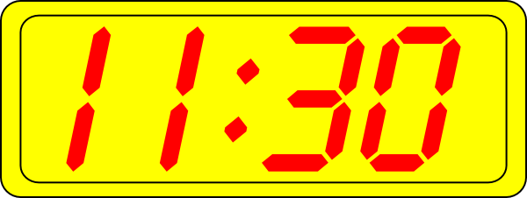 ………………………………………………. 4.  ……………………………………………………..
2.  ………………………………………………. 5. 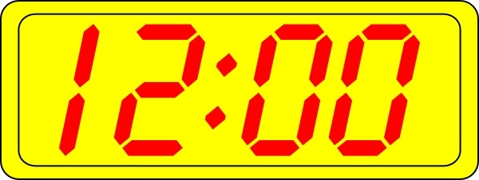 …………………………………………………….
3.  ………………………………………………..
E)Match the pictures with the words.(Resimleri kelimelerle eşleştirin) (2pts)
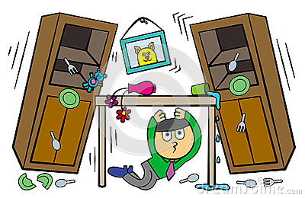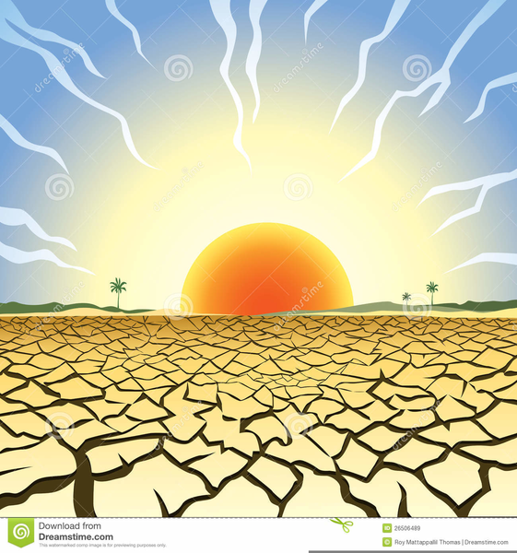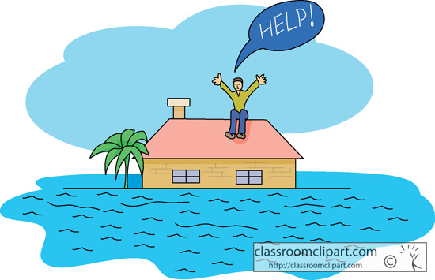
(……..) (……..) (……..) (……..) (……..)
a)drought b)flood c)earthquake d)volcanic eruption e)tsunami

F)Complete the sentences using ‘Simple Present Tense’.(Geniş zaman kullanarak cümleleri tamamlayın)(2p)
1.I ______________ to dance club every Sunday. (go)
2.My mother ______________ a book in the evenings. (read)
3.She __________________ football. (not/play)
4.He _______________ lunch at the school canteen. (have)
5.Tom and Jack ________________ hamburgers. (not/eat)
6.Robert _______________ romance movies. (love)
G)Complete the sentences using ‘Do’ or ‘Does’.(Cümleleri ‘Do’ ya da ‘Does’ kullanarak tamamlayın ) (2pts)
1.Why _______ fail in the exam?
2.What time _______ she g oto school?
3.How many egss ______ you need?
4._______ they like horror movies?
5._______ Marry go to chess club after school?
6._______ you love me?
7._______ he agree with you?
8._______ Mel and Mike go to the same school?
H)Write questions for the underlined words.(Altı çizili kelimelerin sorularını sorunuz.) (2pts)
* Jack always gets up early. *Susan goes to school at 7 o’clock.
1 2 3 1 2 3
- ………………………………………………………………………… 1. …………………………………………………………………………
2. ………………………………………………………………………… 2. …………………………………………………………………………
3. ………………………………………………………………………… 3. …………………………………………………………………………
I)Complete the sentences below with ‘can’ or ‘can’t’ using the information in the chart. (1p)
(Tabloda verilen bilgilere göre cümleleri ‘can’ ya da ‘can’t’ kullanarak tamamlayınız. )
 | Jack | Ali | Mary
ride a bike |  | 
dive
swim
climb mountains

1.Jack ________ swim but he ________ dive.
2.Ali ________ dive but he ________ swim.
3.Mary _______ climb the mountains but Jack and Ali ________.
4.Jack _______ ride a bike but Ali _______.
5.Mary _______ dive or swim.
☺ GOOD LUCK☺

