Soru 1  Verilen cümleye anlamca en yakın seçeneği bulunuz.  John hates walking, so he always takes the bus to work.  A) John likes getting on the buses, so he doesn't walk to work.  B) John takes the bus to work everyday because he doesn't like walking.  C) John likes walking, so he always goes to work on foot.  D) He never goes to work because he doesn't like walking.  E) John prefers walking to taking the bus while going to work.  Soru 2  Boşluğa gelebilecek en uygun seçeneği bulunuz.  I am a sensitive person. So, ...... . 'Titanic' is my favourite one. I can't stop crying whenever I watch the legendary love of Jack and Rose. It seems impossible to experience such a deep feeling.  A) They travel together  B) I am in the movie Club at school  C) I prefer watching romantic movies  D) Titanic is a huge ship  E) Travelling is my favourite hobby.  Soru 3  There are sometimes advantages and disadvantages of being a member of a large family. I have four sisters. We know our responsibilities and how to share our duties. We help each other with every work. My elder sister helps my younger sisters with their homework. We never feel solitary. Because we always smile and we are sociable. We really get on well. I am so happy that I am a member of a big family.  What is the meaning of the underlined word ?  A) busy  B) happy  C) alone  D) distance  E) duty  Soru 4  Soruyu parçaya göre cevaplayınız.  There are some kinds of films, such as romantic comedies, musicals, action, war and horror films. Horror films are thrilling and full of fear. Romantic comedies are funny and entertaining. Action films are fast and gripping. Sometimes they cause excitement. War films are full of violence. Musicals are dull and slow.  According to the text above, when you watch a horror film, you ...... .  A) clap and get happy  B) cry  C) feel scared  D) laugh  E) dance  Soru 5  Choose the correct option.  Tim: Would you like to go to the rock concert with me?  Linda: Rock music is not very me. Thanks.  Linda means ...... .  A) I will join you, thanks.  B) I love rock music, thanks.  C) I don’t like rock music, thanks.  D) I don’t hate rock music, thanks  E) I am too busy to join a rock concert.  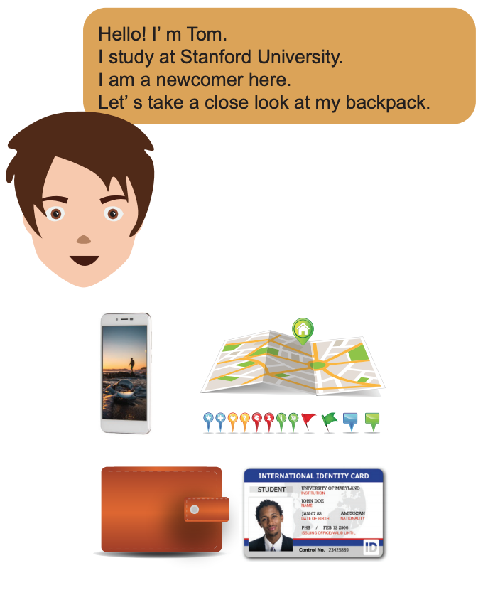  Soru 6  Which object has NOT John got in his backpack?  A) An ID Card  B) A wallet  C) A telephone  D) A map  E) A passport  Soru 7  Soruyu parçaya göre cevaplayınız.  I live in a big city. It has a lot of shops, cinemas and banks. The shops are open from 9 am to 10 pm. They sell everything you need. There are three big cinemas and you can see different kinds of movies there. The banks are open from 9 am. to 5 pm. (Monday to Friday). They are closed at weekends but you can get money from ATMs whenever you want.  How can you get money at nights?  A) You can go to the bank.  B) You can't get money at night.  C) You can use ATMs.  D) The banks aren't closed at nights.  E) The banks are open from Monday to Friday.  Soru 8  Boşluklara gelebilecek en uygun seçeneği bulunuz.  Dave : ...... join my garden party next week?  Susan : OK, I will be there.  A) Do you fancy  B) Do you mind  C) Do you like  D) Would you like to  E) Would you mind  Soru 9  Aşağıdaki cümleye anlamca en yakın seçeneği bulunuz.  'Gangs of New York' is more successful than 'Black Sunday'.  A) 'Gangs of New York' is as successful as 'Black Sunday'.  B) 'Black Sunday' is more successful than 'Gangs of New York'.  C) 'Black Sunday' is the most successful movie of all.  D) 'Black Sunday' isn't as successful as 'Gangs of New York'.  E) 'Gangs of New York' isn't more successful than 'Black Sunday'.  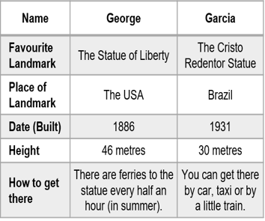Soru 10  Soruyu verilen tabloya göre cevaplayınız.  According to Garcia, which sentence is true?  A) I have been in the USA and visited the Statue of Liberty. It's a gift from France to the citizens of the USA.  B) I have been in Brazil and visited the Cristo Redentor Statue. It was dedicated to the country in 1886, so it's over a hundred years old.  C) I have been in Brazil. There are ferries to the statue every half an hour in summer and it takes only 12 minutes to get there.  D) I have been in Brazil and visited the Cristo Redentor Statue. Paul Landowski, a French artist made it in 1931.  E) I have visited the Statue of Liberty. It is almost 46 metres high and you can reach half way up with a lift. | Soru 11  Cümleyi tamamlayan seçeneği bulunuz.  When Mary goes out in spring, she always ...... because of the pollen in the air.  A) laughs  B) cries  C) smells  D) sneezes  E) examines  Soru 12  Soruyu parçaya göre cevaplayınız.  Polar bears are wild and furry. They are beautiful and powerful. They weigh between 700 and 900 kg but they are fast runners. The average length is around 206 cm. They can live in freezing cold. Their thick fur can keep them warm in winter. They are big mammals. They can smell from up to 16 km away. They can swim very well. They are carnivorous and they feed on fish and seals. They give birth to two cubs every three years.  According to the text, polar bears ...... .  A) feed on plants and roots  B) can't live in cold weather  C) are small animals  D) give birth once a year  E) are giant animals  Soru 13  Diyalogu tamamlayan en uygun ifadeyi bulunuz.  A) the thirteen of December, twenty-sixteen  B) the thirty of December, twenty-sixteenth  C) the third of December, twenty-sixty  D) the thirteenth of December, twenty-sixteen  E) the three of December, twenty-sixteen  Soru 14  What time do you get up? (08:30 a.m.)  A) At eight past thirty  B) At thirty to eight  C) At half past eight  D) At thirteen past eight  E) At thirteen to eight  Soru 15  Gizem has got good friends in Antalya and when her company sends her there for a job, she kills two birds with one stone. After she finishes her work, she visits her friends and they have fun together.  The expression in the underlined part means ......  A) likes killing birds.  B) throwing stone into the air.  C) achieving two things with one action.  D) playing with birds and stones.  E) being good at friendship.  Soru 16  Aşağıdaki soruda boşluklara gelebilecek en uygun seçeneği bulunuz.  On weekdays, I have to ...... early. After breakfast, I have to ...... the school bus and ...... at school for 8 hours. In the evening I have to ...... the ironing for my mother. It's really hard to be a student and a member of a family.  A) get up / catch / study / do  B) sleep / go / do / make  C) get dressed / walk / play / do  D) get up / study / catch / do  E) wake up / take / do / make  Soru 17  Boşluğa gelebilecek en uygun seçeneği bulunuz.  Madonna is a successful ...... . I am a big fan of her.  A) author  B) actor  C) celebrity  D) scientist  E) teacher  Soru 18  Norah: How often do you go to the cinema?  Emma: ......  A) I think they are nonsense.  B) I go on a picnic every weekend.  C) I don’t go to school at weekends.  D) I am going home now.  E) I go there once a week.  Soru 19  Sorudaki boşluğa gelecek uygun ifadeyi bulunuz.  In ...... movies, I feel more thrilled and scared than other films.  A) documentary  B) drama  C) animation  D) romance  E) horror  Soru 20  Verilen parça iki paragrafa ayrıldığında, ikinci paragrafın başladığı cümleyi bulunuz.  (I) San Francisco is the cultural and financial city of California in the USA. (II) It is a popular tourist destination and famous for its cool summers, fog, the Golden Gate Bridge and Alcatraz jail. (III) It has some nicknames like "Fog City" and "The Paris of the West". (IV) Homelessness is always a big problem in this city. (V) The homeless population is nearly 6,500. (VI) These people live on the streets.  A) I  B) II  C) III  D) IV  E) V
CEVAPLAR: 1-B 2-C 3-C 4-C 5-C 6-E 7-C 8-D 9-D 10-D 11-D 12-E 13-D 14-C 15-C 16-A 17-C 18-E 19-E 20-D

