……………………………… EDUCATIONAL YEAR …………………… AND VOCATIONAL ANATOLIAN HIGH SCHOOL THE 1ST TERM THE 2ND WRITTEN ENGLISH EXAM FOR THE 9TH GRADE
Name-Surname:…………….
Number: …..……..
Class: 9 / ….…..
PEOPLE | JEREMY | RICK | MICHAEL | LUCY
AGE | 33 | 26 | 18 | 26
WEIGHT | 85 kg | 63 kg | 67 kg | 78 kg
HEIGHT | 1.85 m | 1.72 m | 1.77 m | 1.63 m

A)CIRCLE THE CORRECT OPTION

1- Complete the dialogue.
Eylül: Where are you from?
Callia:I’m from ________ . I’m __________.

a) Canadian/ American b)Greece/Greek
c)China/Turkey d)Turkish/Turkey
e)Japanese/Chinese

2-Complete the dialogue.
Lily :_________ morning, Brad.
Brad : Hi, Lily. How are__________?
Lily : I’m fine, thanks. And__________?
Brad :________ am OK, thanks.

a) good / you / you /I
b) nice /you / your/I
c) good/you/you/my
d) good/ your/you/my
e) nice /you/my/I

3- Which one of the followings is irrelevant?
Şilan: Excuse me, How can I get to the post-office?
Olida : _______________________.
a)Go ahead and you will find.
b)Take this road. It is opposite the bus stop.
c)It is not far, go down this street and turn left.
d)I’m looking for this address.
e)Go ahead and take the second turning.

4-Which sentence gives wrong information?
a)We buy meat in the butcher.
b)We buy some bread in the bakery.
c)We have lunch in the cinema
d)We read books in the library.
e)We can see animals in the zoo.

5-Look at the comparative and superlative form of the adjectives and circle the wrong option.
a) good-better-best
b)bad-badder-worst
c)far-farther-farthest
d)little-less-least
d)bad-worse-worst

Answer the following three questions according to the table.

6-Which one is false?
a)Jeremy is older than Rick.
b) Jeremy is the tallest of all.
c) Lucy is heavier than Rick.
d) Rick is younger than Lucy.
e) Jeremy is the heaviest of all.

7-Which one is true?
a) Rick is the youngest of all.
b) Lucy is younger than Rick.
c)Micheal is younger than Rick.
d)Lucy is heavier than Jeremy.
e) Micheal is older than Rick.

8-Who is the heaviest?
a)Jeremy b)Rick c) Michael
d)Lucy e)Michael and Lucy

9-Which ones of the followings are true?
1.This film is about future,space travel and robots. science fiction
2.Love and romance are the major topics in this film.romantic comedy
3.The characters and the topic are very comic in this film. comedy
4.There are cowboys and horses in this film. western
5. A film tells an exciting story about a murder historical

a)1-2-4 b)2-4-5 c)1-4-5 d)1-2-5 e)1-3-4

10- Which word is not related to the others?
a) director b)actor c)cast
d)stream e)scenario

11- Complete the sentence.
“Titanic is a spectacular film._________ don’t come much bigger or beter than this.”

a)Blockbusters b)love story
c)Romantic film d)horror e)cinema

12- Acccep the invitation.
Berfin:Why don’t we watch Ice age 7 ?
Sinem:________________ .

a)I’d love to but I have other plans.
b)I guess it is terrible.
c)I’d love to watch with you.
d)I’m afraid I can’t.
e)That sounds bad.

13-Refuse an invitation.
Ada: Would you like to come to the shopping mall?
Hazal:__________________

a)I’d love to.
b)That’s not a good idea.
c)I’d love to do that.
d)That sound great.
e)That’s a very good idea.

14- Complete the sentence.
“How about ________ a war film?”
a) watch b)to watch
c)will watch d)watching e)to watching

15-Which one cannot be used for expreessing oppinion?
a)I think b)I guess
c)I’m sorry d)Personally e)I believe

16- Find the different pronunciation.
a)cooks b)hates c)stops
d)walks e)teaches

17-Complete the dialogue.

Erin: When is your birthday?
Umut: It is ______ July 11th, 1989.

a)under b) in c) at d) on e)from

18- Complete the dialogue.
A: _________ Paul and Mary go out for dinner?
B:Paul and Mary sometimes go out for dinner.

a)What b) How
c)How often d)What type e)When

19- Complete the sentence.
I usually get up_______ 8:30 _______the mornings.
a) in / at b) on / in c)at / in
d) at / on e) at / on

20- Complete the sentence.
A: I’m sorry but you________park your car here.
______see the sign?
a) can’t / Can’t you b) can / Can you
c) can’t / Can’t I d) can / Can I e) can/ Can

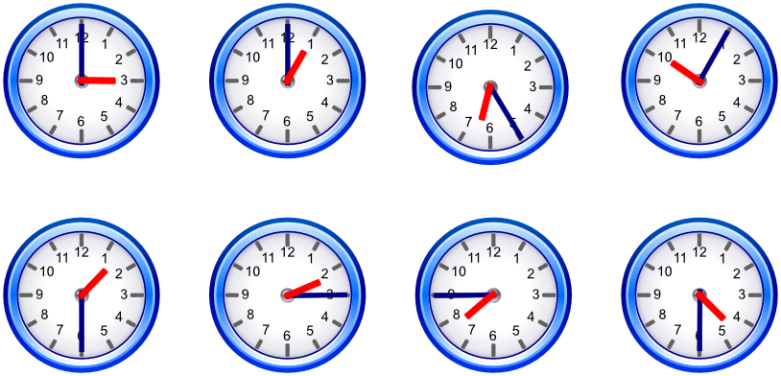
21-What time is it?
a) It’s half past five.
b) It’s ten past five.
c) It’s half past to four.
d) It’s five past ten.
e)It’is six past four.

22- Complete the sentences.
“A hurricane is a natural disaster but it _________ happen in Turkey. But, landslides, earthquakes and avalanches __________ every year.”

a) does not / occur b) is not / are
c) do not / occurs d) never / do not occur
e) always / does not occur.

23- Which one is not exist among the pictures.

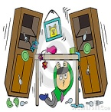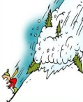
a) flood b) earthquake
c) avalanche d) drought e)tsunami

24-Which one is wrong usage of grammar.?

a) Asya sometimes plays tennis
b) Do you usually drink milk in the morning?
c) I do always my homework
d) My father watches TV every evening.
e) Toprak goes to the cinema twice a year.

25-Which of the adjectives is a bad personal quality?
a)honest b)selfish c)kind
d)friendly e)helpful

