A. MATCH THE PICTURES WITH THE WORDS. (10P)
1. MOTOR RACING 2. PARAGLIDING 3. ICE CLIMBING 4. SAFARI
5. SKATEBOARDING
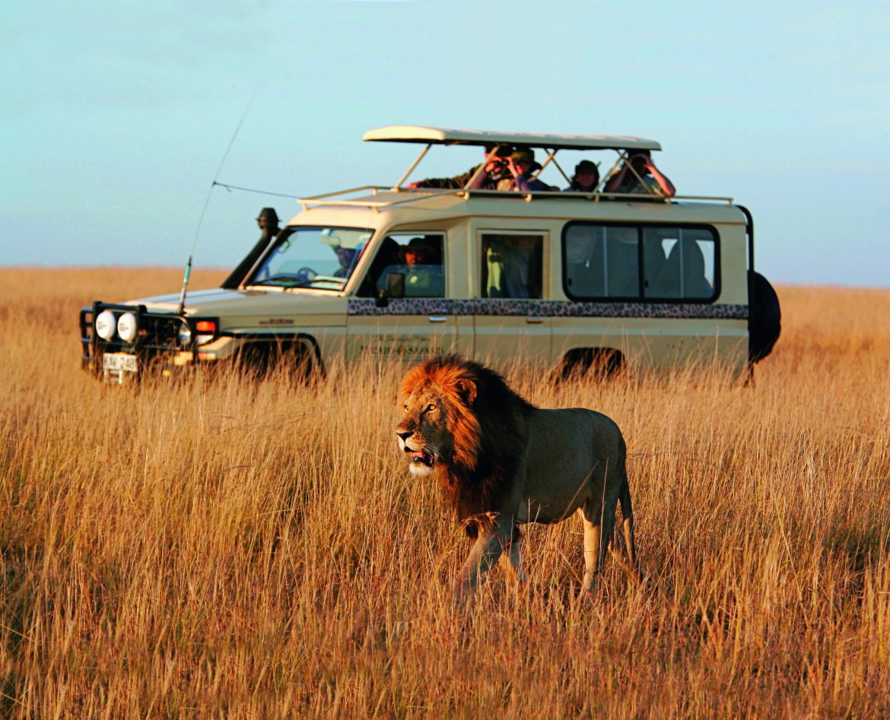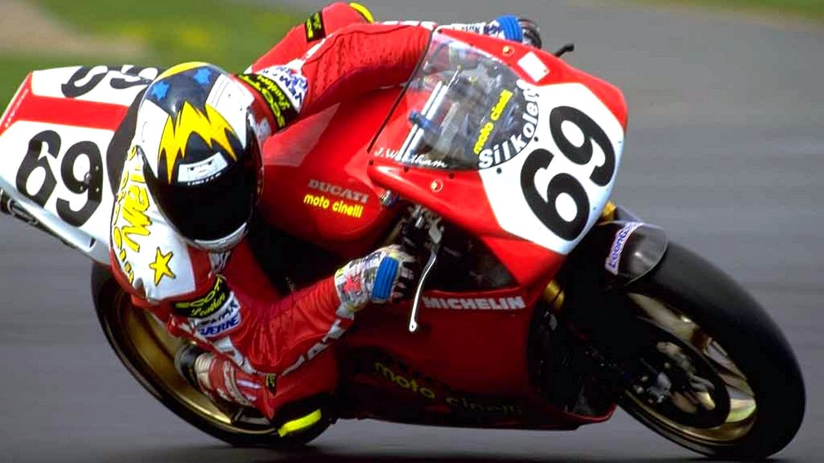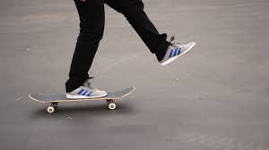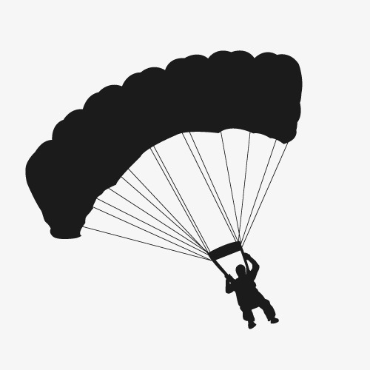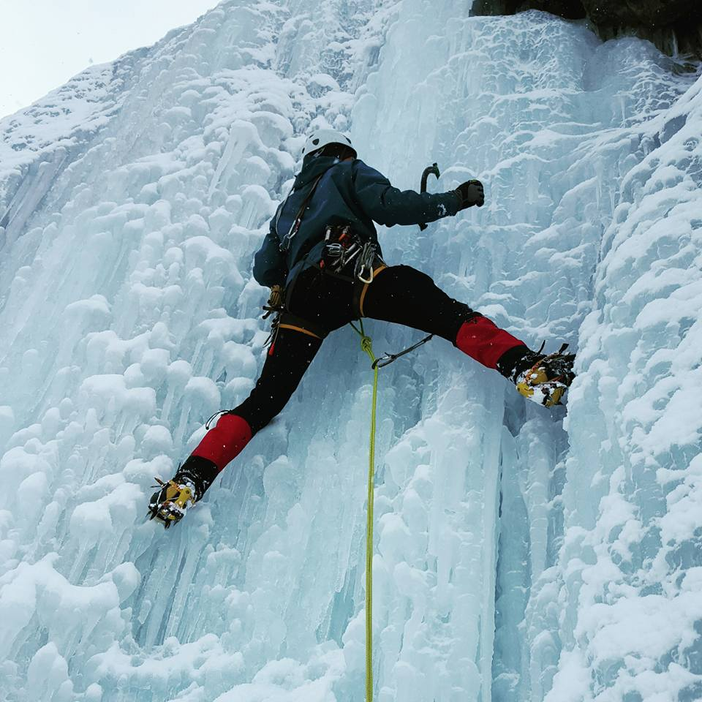

B. FILL IN THE BLANKS WITH “PREFER” or “WOULD RATHER”. (15P)
1. I _________________________ travelling by bus to travelling by train.
2. John _________________________ walking to running.
3. They _________________________ visit historic sites than modern cities.
4. Jack _________________________ watch TV than going out.
5. She _________________________ going to the cinema to sitting at home.

C. MATCH THE WORDS WITH PICTURES . (10X2=20 pts)
log in - comment - connection – log off – download – confirm – attachment – delete – reply – upload

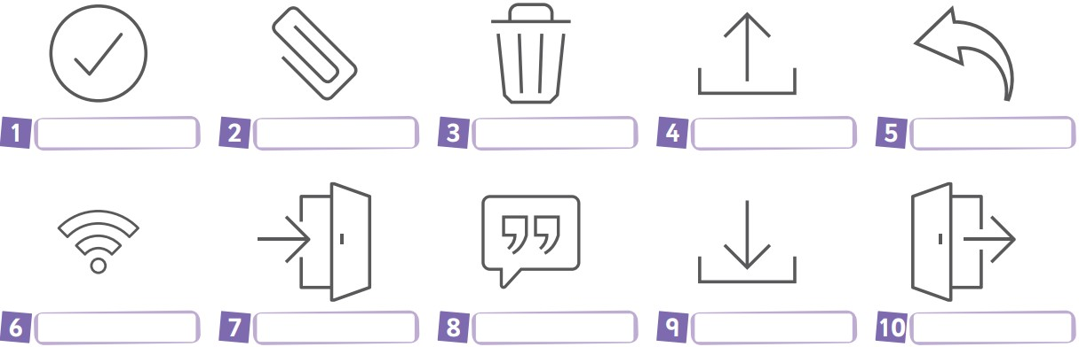
D. CATEGORISE THE WORDS. (20P)
South – plane – bed and breakfast hotel – east – tirit – Blue Mosque -- lentil soup--
Harran Castle – train – all-inclusive resort

LOCATION | TRANSPORTATION | TRADITIONAL DISHES | ATTRACTIONS | ACOMMODATION

E. MATCH THE WORDS WITH THE PICTURES. (10P)
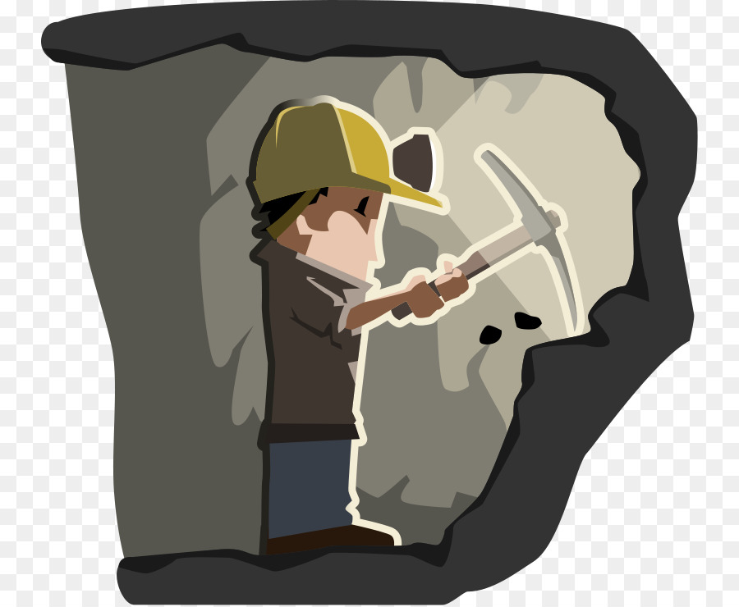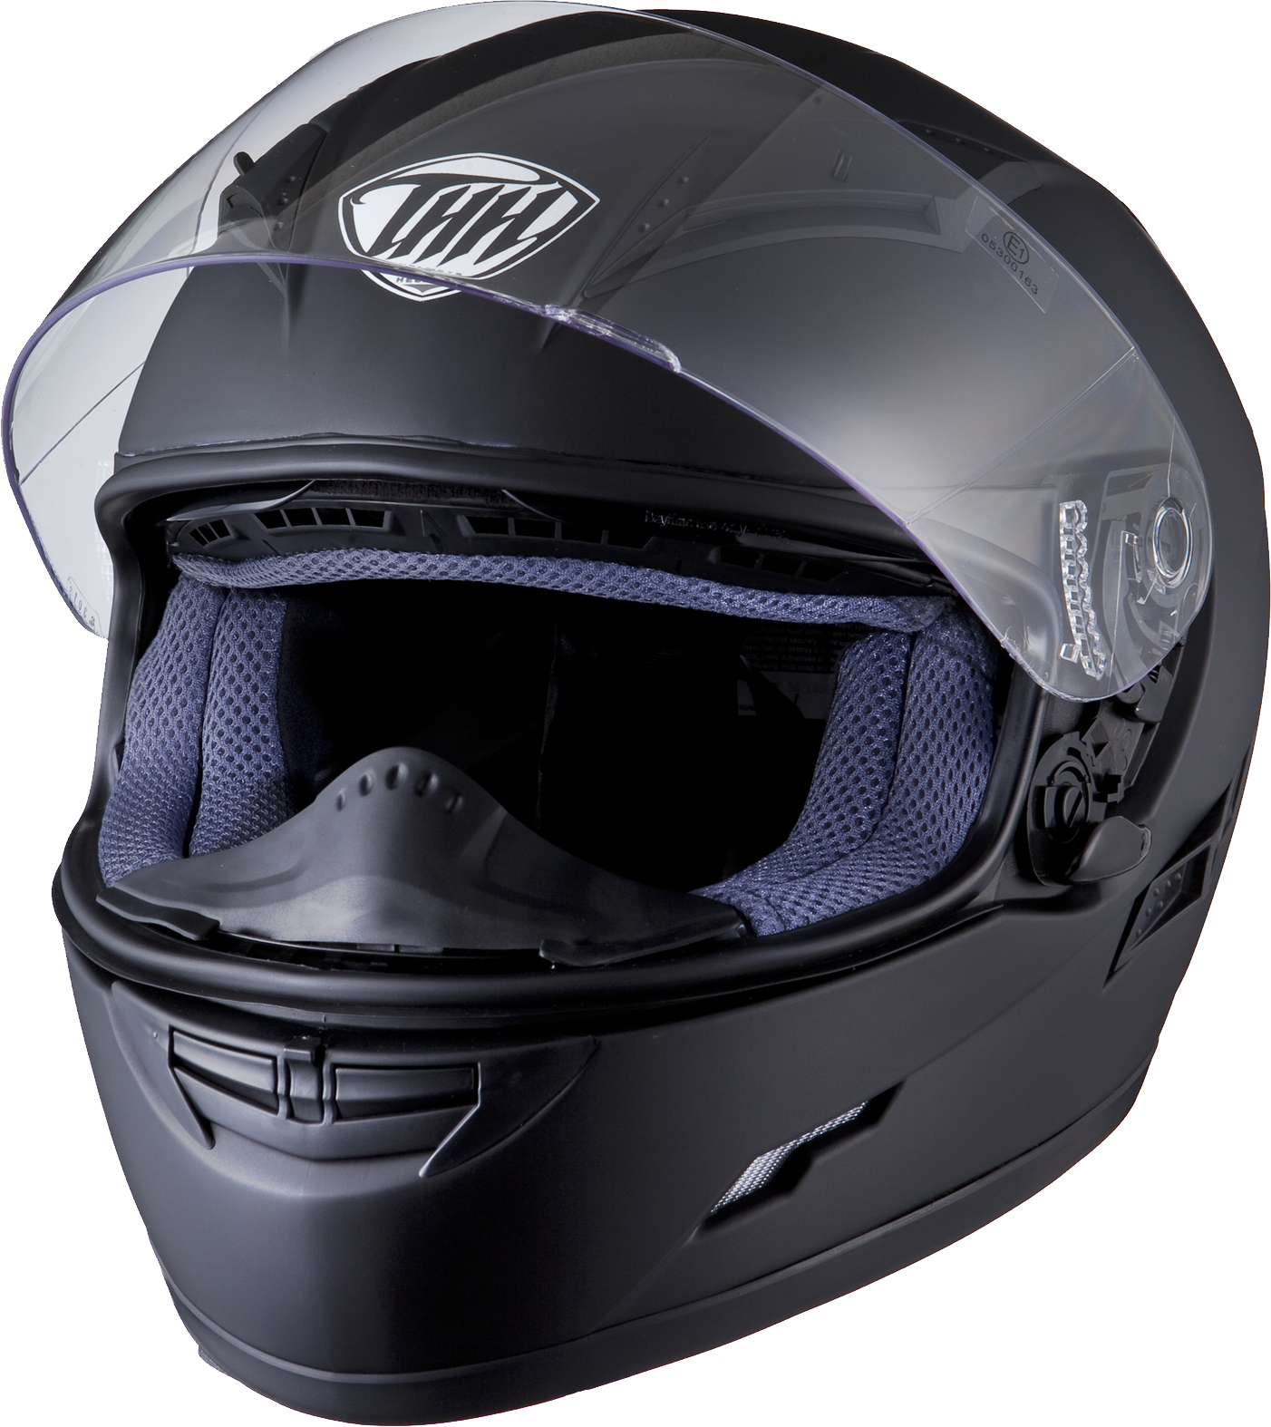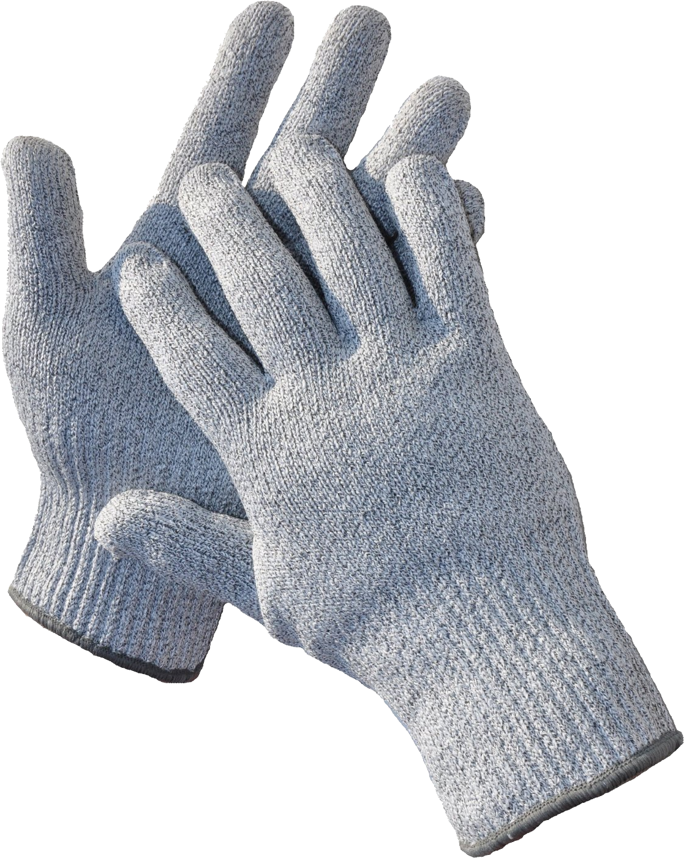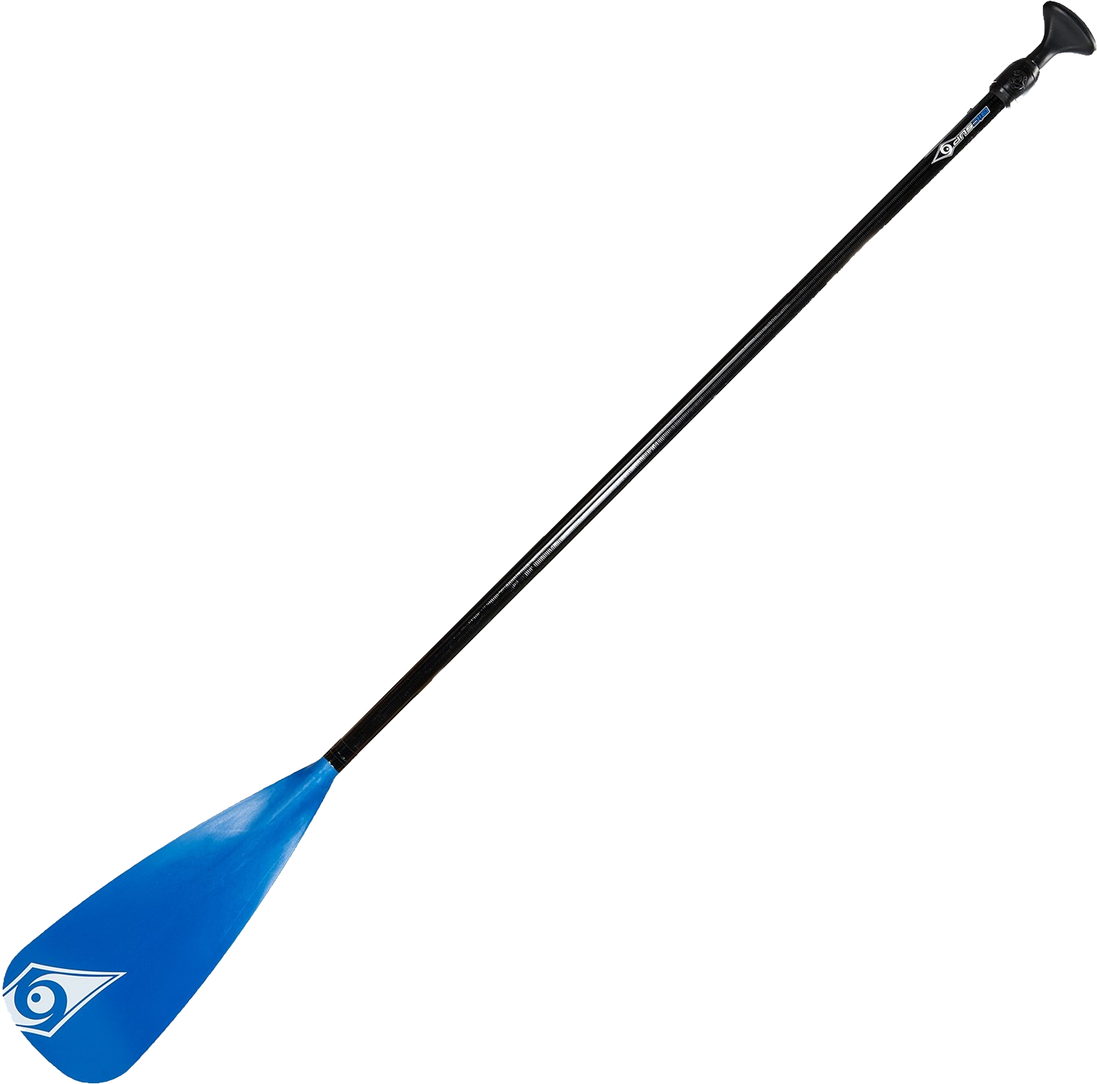
1. HELMET 2. PADDLES 3. GLOVES 4. LIFE JACKET 5. COAL MINER
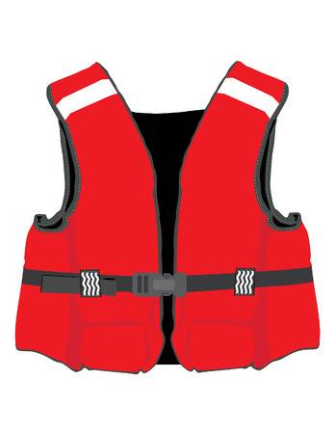

1. Kemal : What did you do there?  Berat : …………………………………………………………  A) It was hot and sunny.  B) The traditional dishes were delicious.  C) The climate is tropical.  D) I joined boat tours in the sea. | 2. I prefer hang-gliding to cycling because it is ……………… and I am an adrenalin seeker.  A) easier C) healthier  B) more challenging D) less risky
3. What are some popular tourist attractions in İstanbul?  A) Big Ben. C) Red Square.  B) Ephesus D) Topkapı Palace. | 4. …………………………….. is jumping out of a plane and opening the parachute to slow down.  A. bungee-jumping B. Skydiving  C. kayaking D. Caving
5. John: _________________  Mary: What do you mean?  John: I mean, i like discovering ancient architecture.  A) I prefer beach holiday.  B) I prefer being in the nature.  C) I like extreme sports.  D) I prefer historic places. | 5. Eylül: Which extreme sport do you prefer?  Selim: I prefer skateboarding.  Eylül: What do you need fort his sport?  Selim: _________________________.  - Because I think it is entertaining.  - I would rather mysterious sports.  - A helmet, a skateboard, knee pads.  - Yes, I am keen on challenging sports.
F. MULTIPLE CHOICE (15P)

F. MATCH THE WORDS WITH THEIR MEANINGS. (20P)
1. ancient 6. province a. kentsel e. deneyim
2. architecture 7. urban b. başkent f. gidilecek yer
3. capital 8. experience c. Kısa gezi g. antik
4. destination 9. bridge d. Hediyelik eşya h. mimari
5. souvenir 10. trip e. il i. köprü

