………………….. EDUCATIONAL YEAR VEZIRKOPRU REGIONAL BOARDING SECONDARY SCHOOL
2ND TERM 1ST ENGLISH WRITTEN EXAM OF 8TH-B CLASS

Name Surname: Number : Mark:

- Write the following phrases about Vezirköprü under the correct group .
(Aşağıdaki kelime gruplarını uygun başlıkların altına yazınız.)(10*1=10 pts)

*keşkek * car *mild *Kunduz Forests *Vezir Hotel *bus
*in the middle black sea region in Samsun *kaz tiridi *Şahinkaya Canyon
*Vezirsuyu Nature park

VEZİRKÖPRÜ
Location | Climate | Accommodation | Transportation | Local Food  (Cuisine) | Tourist Attraction
* | * | * | * | * | *
 |  |  | * | * | *
 |  |  |  |  | *

- Look at the sentences and complete them with “prefer “ or “would rather”. (Aşağıdaki cümlelere bakınız ve boşlukları “prefer” veya” would rather “ ile tamamlayınız.)(5*3=15 pts)

- They …………………………………………….. visit historic places than modern ones.
- Do you …………………………………………. going to the cinema to going to the theatre ?
- My parents ………………………………….. go rafting than go caneoing.
- We ………………………………………………. coming with you to staying here.
- I …………………………………………………… hamburger to sandwich.
- Match the tourist destinations with the following pictures.(Aşağıdaki resimlerle turistik yerleri eşleştiriniz)(5*3=15 pts)
The Eiffel Tower | The Statue of Liberty | The Great Pyramid of Giza | Blue Mosque | The London Eye

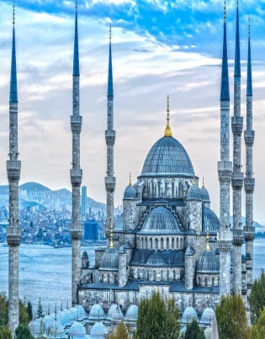 | 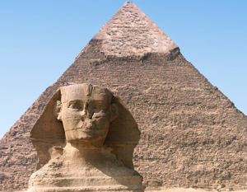 | 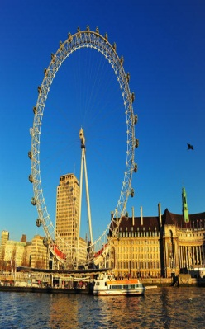 | 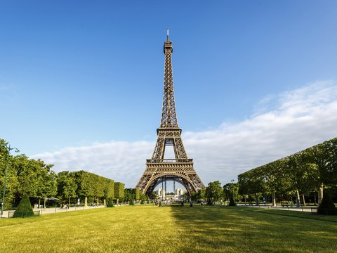 | 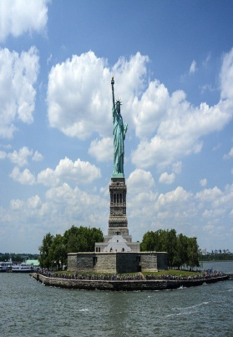

- Match the synonyms of the following words.(Aşağıdaki kelimeleri eş anlamları ile eşleştiriniz.)(5*2=10 pts)
……………1. Historical a) Coast
…………..2. Gorgeous b) Ancient
…………..3. Travel c)Huge
………….4. Beach d)Marvelous
………….5. Large e)Journey
- Complete the sentences with the comparative forms of the adjectives.(Karşılaştırma yapınız.)(5*2=10pts)
- In my opinion skydiving is ……………………………….( amusing ) than parachuting.
- To me, caving is ……………………………………( boring ) than going bungee jumping.
- I think, ice climbing is ……………………………………….( hard ) than rafting.
- Tom’s English mark is …………………..….( good ) than Mary’s English mark.
5.Riding a hot air balloon is ............................... (safe) than going bungee jumping
- Categorize the following words according to their meanings.(Aşağıdaki kelimeleri anlamlarına göre Positive veya negative olarak gruplandırınız.)(10*1=10 pts)
Boring | interesting | Risky | Disappointing | Amazing
Brilliant | Fantastic | Dangerous | Fascinating | Frightening

Positive Meaning | Negative Meaning
- Match the following extreme sports with the following pictures.(Aşağıdaki resimlerle kelimeleri eşleştiriniz)(5*3=15 pts)
*cycling *caneoing *caving *ice-climbing *rafting
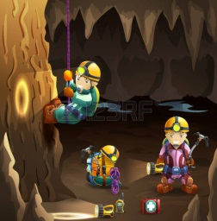 | 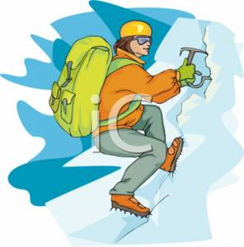 | 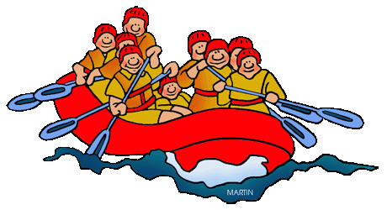 | 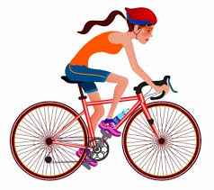 | 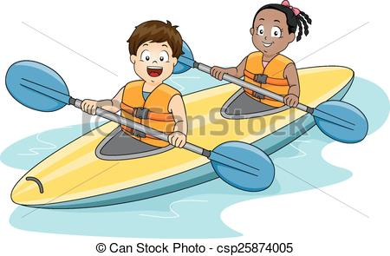

- Look at the chart and mark the sentences as True or False.(Aşağıdaki tabloya bakınız ve cümlelere True veya False yazınız.)(5*3=15 pts)
Names : | Snowboarding | Rafting | Trekking
Mustafa | X
Ayşe | x |  | X
Hasan |  | x
- Hasan would rather be on the mountains than water . ……………………………
- Ayşe prefers being on the water. ……………………………
- Mustafa is not an adrenalin junkie. ……………………………
- Mustafa likes all of the sports. ……………………………
- Ayşe’s favourite extreme sport is rafting. ……………………………

