……………….. EDUCATION YEAR ………………..SECONDARY SCHOOL
2nd TERM 1st ENGLISH EXAM FOR THE 8TH GRADES **
Name/ Surname: Class/ Number:
- Fill in the blanks with comparative forms of given adjectives. (5x3=15 pts.)
(Boşlukları verilen sıfatın uygun halleriyle doldurunuz.)
- Taking photos of animals is ____________ than scuba diving. (fascinating)
- Caving is _________________ than rafting. (easy)
- Riding an elephant is ____________ than climbing a mountain. (boring)
- Going on a jeep safari is _____________ than joining a motorcycle tour. (bad)
- Climbing is ___________ than swimming. (good)
- Fill in the blanks with “prefer” or “ would rather”. (5x1=5 pts.)
( Boşlukları prefer ya da would rather ile doldurunuz.)
1. I _________________________ travel by bus than travel by train.
2. Aslı _________________________walk than run.
3. They_________________________ visiting historic sites to modern cities.
4. Ali _________________________ watching TV to going out.
5. She_________________________ go to the cinema than sit at home.
- Categorize the given words and write them under correct titles. (12x1=12 pts.)
1.South – 2. Taj Mahal – 3.bed & breakfast hotel – 4.east – 5. hardaliye – 6.warm – 7.fried liver
8.Selimiye Mosque –9.guest house – 10.hot – 11. wickerwork basket 12. fragnant soaps
Location | Souvenirs | Accommodation | Climate | Tourist Attractions | Local Food  (Cuisine)
D)Answer the questions according to the text. (5x2=10 pts.)
Muğla is a city on the Southwest coast of Turkey. The growing city has lots of alternatives such as shopping mall, sports activities, historic sites. Bodrum castle, Kaunos historic site and Ölüdeniz beach are some of the most important places to visit. You can also try paragliding in Ölüdeniz. Approximately nine hundred thousand people live there and it has a coast to Aegean. It has a warm temperature over the year. You should taste the delicious foods. You can choose sour fish, Keşkek and Bodrum dessert Lokma for your dinner.

1) What are traditional dishes?
_______________________________________

2) What is the location of the city? _____________________________________________

3) What is the population in Muğla? _____________________________________________

4) What is the weather like there? _____________________________________________

5) What are some tourist attractions? _____________________________________________
- Fill in the blanks. (Boşlukları doldurunuz.) (8*1=8 points)
Mom Darren Set Sarah Loading Dad Cooking Vacuum
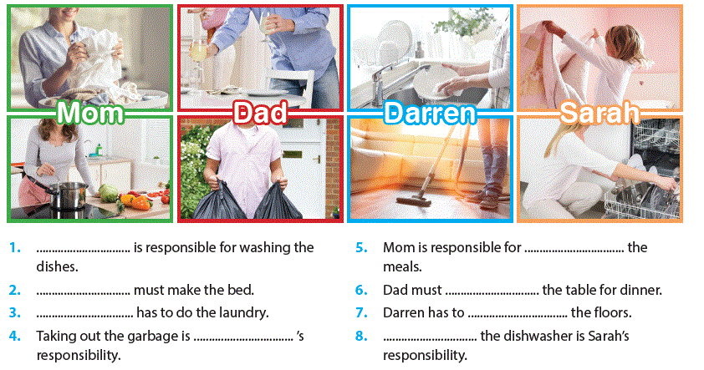
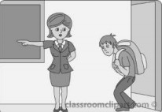
E)ANSWER THE TESTS(20x2,5=50)
Answer the questions 1 2 3 according to the text below
Hi, I am Linda!
Today is Saturday and we are busy with some chores. We emptied the dishwasher, dusted the furniture and washed the dishes but we have still a lot of things to do. First, my sister is going to take out the garbage because the kitchen has unbearable smells, and then I am going to sweep the floors and iron the clothes. We have some guests for dinner so mum will cook dinner and set the table. My father will do shopping, feed the family dog and wash the car.

- The kitchen smells very bad so --.
  - Linda will sweep the floor.
  - Linda's father will wash the car.
  - Linda's sister will take the rubbish out.
  - Linda's mother will do the laundry.

- Which one is true according to the text?
  - Linda’s sister will feed the dog.
  - Linda has already ironed the clothes.
  - Linda’s father will only do inside chores
  - They haven’t finished the houseworks yet.

- Which task is not mentioned in the text?
  - b) c) d)

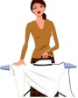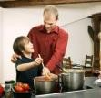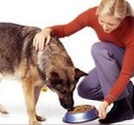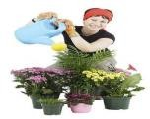

4)
Hüseyin is responsible for emptying the dishwasher but,…………

A he prefers doing it B he is crazy about it
C he must do it D he doesn’t like doing it

5)
You want to have grilled chicken for the dinner.
How do you offer?

- Let’s have chicken BBQ
- Why don’t we have fried chicken.
- What about having boiled chicken.
- Let’s have fried chicken

Answer the questions 6 & 7 according to the picture
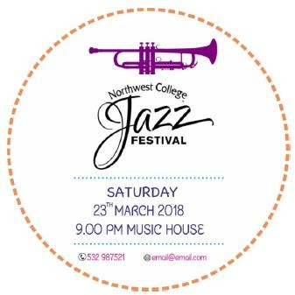
6 Which we can not find in the picture?
A Contact information B The date and the time
C The Price D Music Type
7 This is from a …….
A concert brochure B movie ticket
C flight information D amusement park
8.
Teacher: You are always late, please !

- Keep your desks clean
- Focus on your task
- Don’t eat or drink in the class
- Come to the class on time
9
Bursa has a very rich… You should definitely
try İskender, İnegöl meatball, and candied chestnut.

A) accomodation B) location
C) budget D) cuisine
10 Which synonyms-match is not true?
A travel : marvellous B well-known : famous
C very cold : freezing D duty : task
11 Which one is different from others ?

A l have to B I think
B in my opinion D According to me

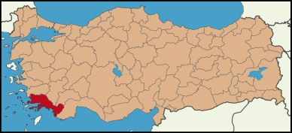
 | Burj khalifa | Eiffel Tower | Pisa Tower
Constructed | in 2010 | in1898 | in1090
Height | 828 m | 324 m | 56 m
Visitors | 5 million | 8million | 1 million

Answer the questions 12, 13 , according to the chart

- Choose the correct option
A Burj khalifa is an ancient structure
B Pisa Tower is a historic building
C Eiffel Tower is older than the Pisa Tower
D Eiffel Tower is taller than the Burj Khalifa

13…….. is not more modern than …
A Pisa Tower / Eiffel Tower
B Eiffel Tower / Pisa Tower
C Burj Khalifa / Pisa Tower
D Burj Khalifa / Eiffel Tower
14 Muğla is located in Anatolia.

- Southwestern
- Northwestern
- Southeastern
- Northeastern

15

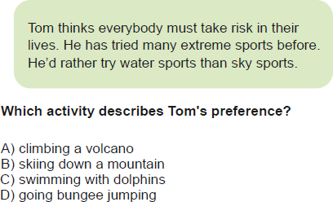

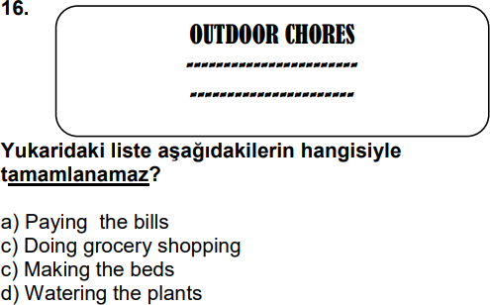

17
Tom is an adrenalin junkie. He loves doing extreme sports but he is afraid of height.
Which sports he can’t do?
A) Rafting B) motor racing
C) Minigolf D) skydiving
18
Aslı : Have you tried any different sports ?
Jale : Yes, I tried in Muğla. It was adventurous.

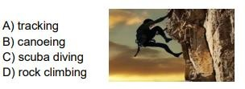
Answer the questions 19 & 20 according to the text below

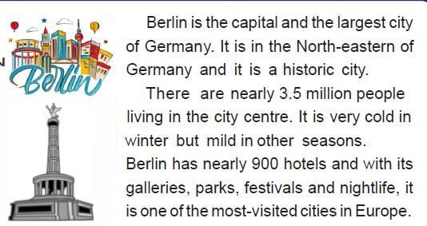
19 There is no information about -----.

- transportation B) accomodation
C) location D) climate
20 According to the text;

- Berlin is boiling hot in winter
- The city is not so old. It is new.
- There are more than five hundred hotels
- Berlin is in Italy
CEVAP ANAHTARI
YOUTUBE NURFER TAVŞANKORU

