……………….. EDUCATION YEAR CENGİZ TOPEL SECONDARY SCHOOL
8th GRADES 2nd TERM 1st ENGLISH COURSE EXAM
Name & Surname : A No:
scuba diving - highlining - mountain biking - paragliding - trekking
kayaking - skateboarding - sailing - hang gliding - canoeing
1.Categorize the following sports. (Aşağıdaki sporları kategorilere ayır.) (10 points)
SKY SPORTS WATER SPORTS OTHER SPORTS

2. Choose the correct word. (Doğru kelimeyi seç.) (12 points)
1. Bungee jumping is a fascinating / challenging / entartaining sport but I like it a lot.
2. It is really fun to go and protect / require / explore mysterious caves.
3. She always tries extreme sports because she has got safety / courage / view.
4. You can use a torch / paddle / googles to see better at night.
5. We saw an amazing occupation / individual / scenery when we climbed the mountain.
6. I need an experienced nervous / instructor / equipment to learn scuba diving.

3. Make comparative sentences. (Karşılaştırmalı cümleler yap.) (15 points)
rock climbing ✓ - canoeing X (dangerous)
_____________________________________________________________

hang gliding X - caving ✓ (easy)
_____________________________________________________________

sky diving X - ice climbing ✓ (entartaining)
_____________________________________________________________

rafting ✓ - heli-skiing X (safe)
_____________________________________________________________

windsurfing X - parachuting ✓ (boring)
_____________________________________________________________

4. Circle the correct one. (Doğru olanı yuvarlak içine al.) (14 points)
1. What does she prefer do / doing when she in on holiday?
2. Mike prefers / would rather try motor racing.
3. I would rather meeting / meet my friends to / than play video games.
4. They prefer windsurfing to / than sailing because they think it is more exciting.
5. Tom prefers stay / staying at home tonight to / than going out.

5. Write the words under the pictures. (Kelimeleri resimlerin altına yaz.) (10 points)
castle - beach - resort - construction - lake - statue - bridge - church 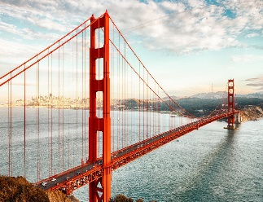 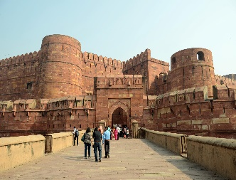 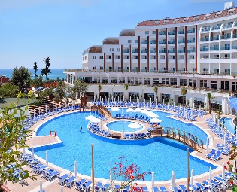 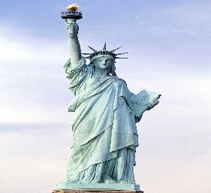 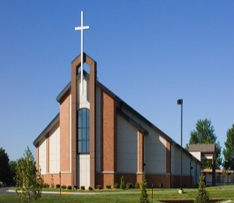
_______________ _______________ _______________ ______________ _______________

6. Fill in the blanks with the following words. (Boşlukları aşağıdaki kelimelerle doldur.) (12 points)
souvenir - climate - attractions - destination - recreational - ancient - sightseeing - square

- There are a lot of tourist ............................... in Paris.
- Roma is a beautiful holiday ............................... for a lot of people.
- When you go to New York, can you buy a ............................... for me?
- Taksim is a big and popular ............................... in İstanbul.
- Antalya is a great city for ............................... activities.
- She is interested in history. So, she always visits ............................... monuments and temples.

7. Match the questions with the answers. (Soruları cevaplar ile eşleştir.) (12 points)

____ When did you come back? A – About three days.
____ How long did you stay there? B – With my friends.
____ Where did you stay? C – Because I liked it.
____ Did you visit Hasankeyf Castle? D – At a hostel.
____ What was the weather like? E – It was very cold.
____ Who did you go with? F – Yes, it was great.
G – Last weekend.
8. Write the Turkish of the following words. (Aşağıdaki kelimelerin Türkçelerini yaz.) (15 points)
bungee jumping : souvenir :
wrist guards : ancient :
safe : experience :
extreme : accommodation :
mysterious : trip :
rope : historic site :
fascinating : attraction :
instructor :
GOOD LUCK!
ERKAN TOY – TEACHER of ENGLISH
2019-2020 EDUCATION YEAR CENGİZ TOPEL SECONDARY SCHOOL
8th GRADES 2nd TERM 1st ENGLISH COURSE EXAM
Name & Surname : B No:
1. Choose the correct word. (Doğru kelimeyi seç.) (12 points)
1. She always tries extreme sports because she has got safety / view / courage.
2. I need an experienced nervous / equipment / instructor to learn scuba diving
3. We saw an amazing scenery / individual / occupation when we climbed the mountain.
4. You can use a paddle / torch / googles to see better at night.
5. Bungee jumping is a fascinating / challenging / entartaining sport but I like it a lot.
6. It is really fun to go and explore / protect / require mysterious caves.

2.Categorize the following sports. (Aşağıdaki sporları kategorilere ayır.) (10 points)
hang gliing - trekking - canoeing - paragliding - sailing
mountain biking - skateboarding - highlining - scuba diving - kayaking
WATER SPORTS SKY SPORTS OTHER SPORTS

3. Make comparative sentences. (Karşılaştırmalı cümleler yap.) (15 points)
rock climbing ✓ - canoeing X (dangerous)
_____________________________________________________________

windsurfing X - parachuting ✓ (boring)
_____________________________________________________________

hang gliding X - caving ✓ (easy)
_____________________________________________________________

sky diving X - ice climbing ✓ (entartaining)
_____________________________________________________________

rafting ✓ - heli-skiing X (safe)
_____________________________________________________________

4. Circle the correct one. (Doğru olanı yuvarlak içine al.) (14 points)
1. They prefer windsurfing to / than sailing because they think it is more exciting.
2. Mike prefers / would rather try motor racing.
3. Tom prefers stay / staying at home tonight to / than going out.
4. What does she prefer do / doing when she in on holiday?
5. I would rather meeting / meet my friends to / than play video games.

5. Match the questions with the answers. (Soruları cevaplar ile eşleştir.) (12 points)

____ What was the weather like? A – Last weekend.
____ Did you visit Hasankeyf Castle? B – It was very cold.
____ Where did you stay? C – With my friends.
____ Who did you go with? D – About three days.
____ When did you come back? E – Yes, it was great.
____ How long did you stay there? F – Because I liked it.
G – At a hostel.
6. Write the words under the pictures. (Kelimeleri resimlerin altına yaz.) (10 points)
lake - bridge - church - statue - beach - resort - castle - constrcution
_______________ _______________ _______________ ______________ _______________

7. Fill in the blanks with the following words. (Boşlukları aşağıdaki kelimelerle doldur.) (12 points)
ancient - sightseeing - recreational - climate - square - souvenir - destination - attractions

- Taksim is a big and popular ............................... in İstanbul.
- Antalya is a great city for ............................... activities.
- She is interested in history. So, she always visits ............................... monuments and temples.
- When you go to New York, can you buy a ............................... for me?
- Roma is a beautiful holiday ............................... for a lot of people.
- There are a lot of tourist ............................... in Paris.

8. Write the Turkish of the following words. (Aşağıdaki kelimelerin Türkçelerini yaz.) (15 points)
extreme : historic site :
safe : attraction :
instructor : trip :
fascinating : ancient :
rope : experience :
bungee jumping : souvenir :
mysterious : accommodation : wrist guards :
GOOD LUCK!
ERKAN TOY – TEACHER of ENGLISH

