…………. ACADEMIC YEAR MEHMET AKİF ERSOY SECONDARY SCHOOL 2nd TERM 1st WRITTEN ENGLISH EXAM FOR 8th GRADES
Name- Surname: Class: Grade: ______/100
A. Boşlukları comparative form (karşılaştırma cümleleri) ile doldurunuz (1x10=10 Pts)
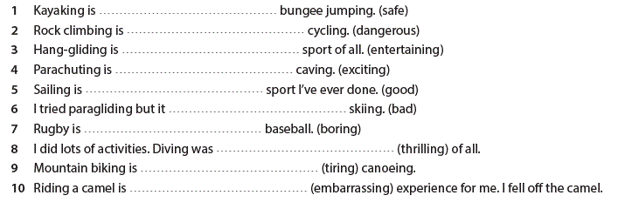
B. Boşlukları "prefer" ya da "would rather" ile doldurunuz. (5 Pts)
- I ______________ going kayaking to going scuba diving.
- Alper __________________ see historic places than modern buildings.
- Semih __________________ going caving to scuba diving because he is not good at sea sports.
- Başak ____________________ stay in a all inclusive hotel than stay in a bed and breakfast hotel.
- Mark _____________________ do outdoor sports than indoor sports.
C. Sporların numaralarını uygun kutucuğun içine yazınız. (10 Pts)
1. kayaking 2. wind surfing 3. hang gliding 4. paragliding 5. skiing 6. ice climbing 7. rafting 8. bungee jumping 9. under water hockey 10. heli skiing
Water Sports | Air Sports | Winter Sports
D. Verilen cümleleri Türkçeye çeviriniz. (4 Pts)
- I would rather visit Venice in Italy because I love ancient cities. _____________________________________________________________________
- I prefer going to Bodrum in Turkey because there are fantastic beaches. ______________________________________________________________________

E. Fiillerin 2. (past) ve 3.(past participle) halleri ile tabloyu doldurunuz. (10 Pts)
go
 | swam
 | brought | brought
give | gave
take |  | taken
put |  | put
 | broke | broken
fly | flew

F. Aşağıdaki soruları metne göre cevaplayınız. (10 Pts)
Australia is a beautiful country. The best time to visit Australia is in January and February because it is usually warmer and sunnier at that time. You can do many activities there. One of the most popular activities is you can go scuba diving in the Great Barrier Reef. Its more fascinating than any other sports. Another activity is a 6 day trekking in Overland Tasmania. You can do bungee jumping in Kingston Park Raceway. Its about 146 Australian dollars per person.

1. What is the best time to visit Australia? ______________________________________
2. How long is the trekking route in Overland? _____________________________________________
3. How much does it cost to do bungee jumping in Kingston Park Raceway? _____________________
4. What are the activities in Australia? ____________________________________________________
5. What does the weather like in Australia in summer? ______________________________________
H. Resimlere bakarak boşlukları verilen kelimelerle doldurunuz. (8 Pts)
Mom Darren Set Sarah Loading Dad Cooking Vacuum

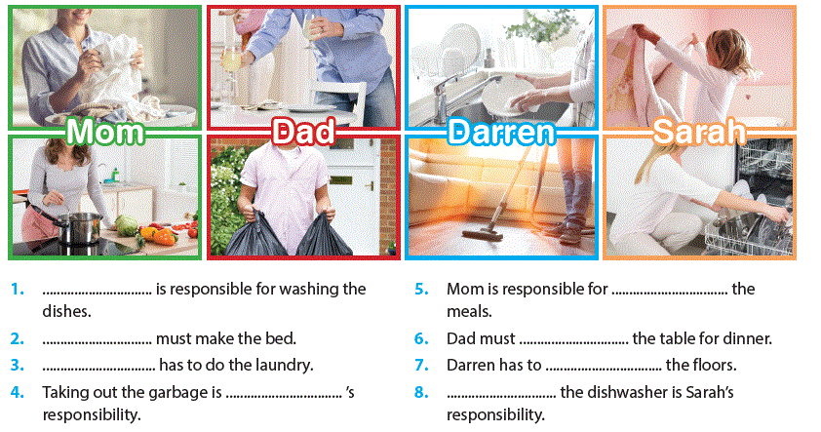
I. Başlıkları yerleştiriniz. (8 Pts)
Things to do Accommodation Ancient Sites Location
1. ............................................................................
Istanbul is in the north West of Turkey. It has coast on the Black Sea and the Marmara Sea. It has land in both Asia and Europe.
2. ................................................................................
You can stay at all-inclusive resorts, small hotels or bed and breakfast hotels.
3. ................................................................................
There are a lot of historic places. You can visit Hagia Sopia, Topkapı Palace, Maiden's Tower, castles and museums. The Bosphorus Bridge has a fantastic view.
4. .................................................................................
You can do shopping in the Grand Bazaar. You can swim in the sea. You can attend a sightseeing tour.

J) Diyaloğu verilen sorularla tamamlayınız. (6x2: 12 pts)
Suzan : Hey, Leyla! It’s nice to see you. 1) ........................................
• Fantastic! • Did you take lots of photos? • What was the weather like?
• Where did you go? • How was your holiday? • Where did you stay?
Leyla : It was 2) ........................................ I had a great time.
Suzan : 3 ........................................
Leyla : I went to İstanbul, Turkey.
Suzan : Wow! 4) ........................................
Leyla : I stayed at a five-star hotel in the centre of the city.
Suzan : That’s great. 5) ...............................................
Leyla : The weather was marvelous. It wasn’t too hot, and it wasn’t too cold. It was just right.
Suzan : Lucky you! 6) ................................................
Leyla : Yes, I did. Would you like to come over later to see them?
Suzan : Sure, that sounds great. See you later.

K. Tabloya bakarak TRUE ya da FALSE doğru olana tik işareti koyunuz.(10 Pts)
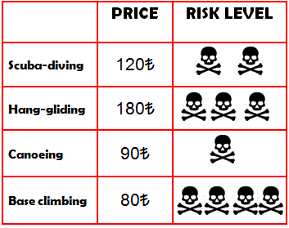
L. Doğru seçenekleri işaretleyiniz. (6 Pts)
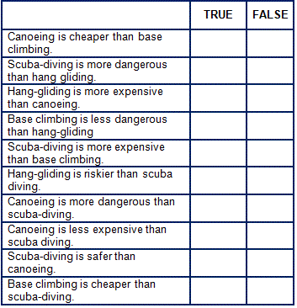
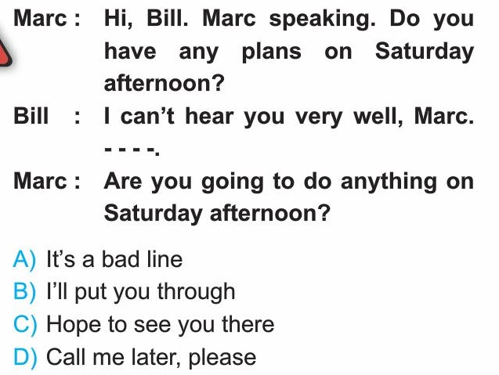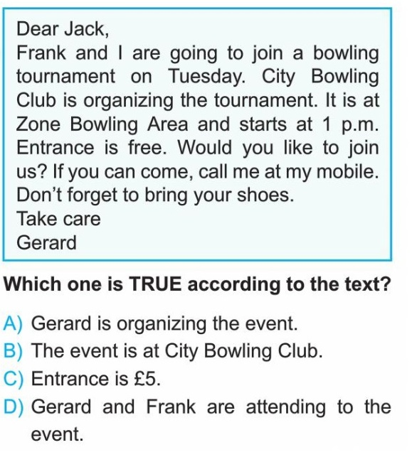

M. Aşağıdaki tabloya bakarak kişi isimlerini yandaki kutucuklara yazınız. (7 Pts)
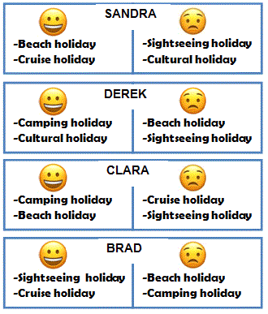
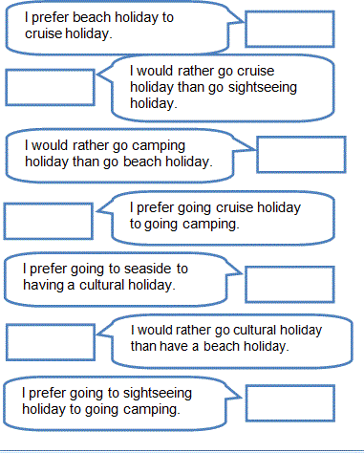

Best of Luck !
Ebru GÜNEŞ - ELT

