…………………… EDUCATION YEAR FATİH SULTAN MEHMET SECONDARY SCHOOL
2nd TERM 1st ENGLISH EXAM FOR THE 8TH GRADES

Name/ Surname: Class/ Number:

- Fill in the blanks with comparative forms of given adjectives. (5x3=15 pts.)
(Boşlukları verilen sıfatın uygun halleriyle doldurunuz.)
- Taking photos of animals is ____________ than scuba diving. (easy)
- Rafting is _________________ than caving. (entertaining)
- Riding an elephant is ____________ than climbing a mountain. (dangerous)
- Going on a jeep safari is _____________ than joining a motorcycle tour. (good)
- Climbing is ___________ than swimming. (bad)

- Fill in the blanks with “prefer” or “ would rather”. (5x2=10 pts.)
( Boşlukları prefer ya da would rather ile doldurunuz.)
1. I _________________________ travelling by bus to travelling by train.
2. Aslı _________________________walking to running.
3. They_________________________ visit historic sites than modern cities.
4. Ali _________________________ watching TV to going out.
5. She_________________________ go to the cinema than sit at home.
- Categorize the given words and write them under correct titles. (12x2=24 pts.)
(Verilen kelimelerin numaralarını uygun kategoriye yazınız.)

1.South – 2.wickerwork basket – 3.bed & breakfast hotel – 4.east –5. hardaliye – 6.warm –
7.Selimiye Mosque –8.guest house – 9.hot – 10. fried liver – 11.Taj Mahal 12. Fragnant soaps

Location | Climate | Accommodation | Souvenirs | Local Food  (Cuisine) | Tourist Attractions

- Answer the questions according to the text. (5x3=15 pts.)
( Soruları parçaya göre cevaplayınız.)
1) What are some tourist attractions? _____________________________________________
Muğla is a city on the Southwest coast of Turkey. The growing city has lots of alternatives such as shopping mall, sports activities, historic sites. Bodrum castle, Kaunos historic site and Ölüdeniz beach are some of the most important places to visit. You can also try paragliding in Ölüdeniz. Approximately nine hundred thousand people live there and it has a coast to Aegean. It has a warm temperature over the year. You should taste the delicious foods. You can choose sour fish, Keşkek and Bodrum dessert Lokma for your dinner.

2) What is the weather like there? _____________________________________________

3) What is the population in Muğla? _____________________________________________

4) What is the location of the city? _____________________________________________

5) What are traditional dishes?
_____________________________________________

- Complete the dialogue with the questions.(Diyaloğu verilen sorularla tamamlayınız. (6x2: 12 pts)
Suzan : Hey, Leyla! It’s nice to see you. 1) ........................................
• Fantastic! • Did you take lots of photos? • What was the weather like?
• Where did you go? • How was your holiday? • Where did you stay?
Leyla : It was 2) ........................................ I had a great time.
Suzan : 3 ........................................
Leyla : I went to İstanbul, Turkey.
Suzan : Wow! 4) ........................................
Leyla : I stayed at a five-star hotel in the centre of the city.
Suzan : That’s great. 5) ...............................................
Leyla : The weather was good. It wasn’t too hot, and it wasn’t too cold.
Suzan : Lucky you! 6) ................................................
Leyla : Yes, I did. Would you like to come over later to see them?
Suzan : Sure, that sounds great. See you later.

- Fill in the blanks. (Boşlukları doldurunuz.) (8*1=8 points)
Mom Darren Set Sarah Loading Dad Cooking Vacuum

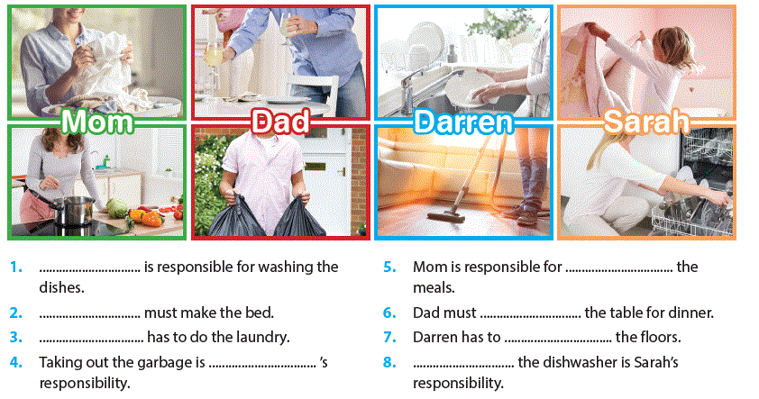

G. Write the numbers. (Sporların numaralarını uygun kutucuğun içine yazınız. (10*1=10 Pts)
1. kayaking 2. wind surfing 3. hang gliding 4. paragliding 5. skiing 6. ice climbing 7. rafting 8. bungee jumping 9. under water hockey 10. heli skiing
Water Sports | Air Sports | Winter Sports

G.Verilen cümleleri Türkçeye çeviriniz. (2*3=6 Pts)
- I would rather visit Venice in Italy because I love ancient cities. __________________________________________________ GOOD LUCK
- Have you ever ridden an elephant? Nihan ALTAN
_________________________________________________ ELT

