……………………. EDUCATION YEAR NECİP FAZIL KISAKÜREK IMAM HATIP SECONDARY SCHOOL 2nd TERM 1st ELECTIVE ENGLISH EXAMINATION FOR THE 8TH GRADES

Name/ Surname: Class/ Number: Grade:___________

- Answer the questions according to the text. (6x2=12)
1) What are some tourist attractions? _____________________________________________

Samsun is a city on the North coast of Turkey. The growing city has a lot of alternatives such as shopping mall, sports activities and opera. The Palace of Culture, Samsun State Opera and Ballet Building and Samsun City Museum are one of the most important places to visit. Nearly 605.000 people live there and it is warm over the year. You should taste the delicious foods. You can choose Haluçka or Tirit for your dinner. There are many accommodation choices such as pensions, bed and breakfast hotels and all inclusive ones.

2) What is the weather like there? _____________________________________________

3) What is the population of Samsun? _____________________________________________

4) What is the location of the city? _____________________________________________
5) What are traditional dishes? _____________________________________________
6) Where can you stay there?
__________________________________________

B. Match the questions with the answers (5X2=10)
1. How do you connect to the internet? (….)
2. Who uses the internet in your family mostly? (…..)
3. What do your mother and father usually do online? (….)
4. How many hours do you spent a day on the net? (….)
5. Are you an internet addict? (…..)

C. Match the halves. (9x2=18)
1. How do you connect to the internet? I mean………..
2. Be careful with what you share on the net. I mean……….
3. Is there a connection sign on the screen? I mean………….
4. You must create online identities to log in. I mean……….
5. Avoid using dangerous sites. I mean……….
6. Why do you like rafting? I mean……….
7. Is it expensive? I mean………..
8. What was the date? I mean…….…
9. Do you like extreme sports? I mean………..

d. Match the pictures with the words. (5X2=10)
a) rafting b) hang gliding c) caving d) bungee jumping e) skateboarding

A. Dad usually does online banking and mom surfs on social networking sites.
B. I usually use my smart phone or tablet.
C. Definitely, not. I am a moderate internet user.
D. Two or three hours.
E. Not, me, my brother. He spends ten hours a day on the net.

a. Is your PC online or offline?
b. do you have a smartphone or laptop with an internet connection?
c. are you an adrenalin seeker?
d. when did yo go there?
e. you should register to the site first
f. what is then reason you enjoy rafting?
g. anything you share on the net can stay online forever
h. use safe sites.
i. how much does it cost to do this sport?

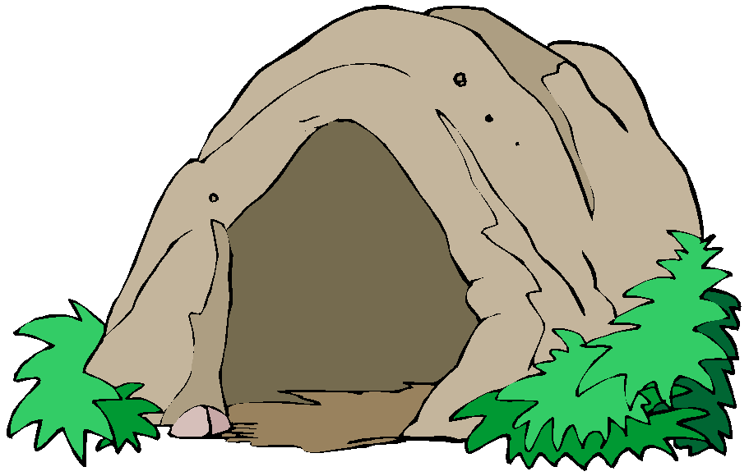
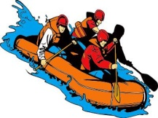
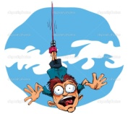

…………… …. …………………….. ………………… ………………


………………………………
E) Choose the correct option. (4X13=52)
- Harry: Where did you go on your last holiday?
Betty: I went to Hawaii.
Harry:______________?
Betty: I went rock climbing and trekking.
I really enjoyed the nature. It was fantastic.
- How was it
- What did you do there
- When did you go there
- What are your favorite activities
2. A lot of people like extreme sports because____.
Which one is NOT suitable for completing this sentence?
- They love dangerous and risky things.
- They want to test their limits.
- They want to see how far they can go.
- They prefer being safe.

3. A: I think skydiving is easier than rafting. What do you think?
B: I don’t think so________.
- rafting is easier than skydiving.
- rafting is more boring than skydiving.
- skydiving is less difficult than rafting.
- I prefer skydiving.
4. Paul: Tell me, Sue. What kind of holidays do you prefer?
Sue: I would rather go sightseeing tour and visit different parts of a place so I prefer……………………

A) cruise holiday B) city holiday
C) nature holiday D) holiday at the seaside
5. ___________, in other words, I like discovering ancient architecture.
- I prefer beach holiday.
- I prefer being in the nature.
- I like extreme sports.
- I prefer historic places.

6. Merve: I spend more than three hours a day on the net.
Nancy: ……………………………..?
Merve: I generally watch foreign serious to improve my English.
A) What do you use the internet for?
B) How much time do you spend online?
C) Who uses the internet most in your family?
D) Do you obey the internet safety rules?

7. INTERNET SAFETY RULES
Don’t share your personal information
Create strong passwords
Don’t open files from people you don’t know
……………………………….…………………………………………
Which one is NOT suitable to complete the list?

A) Before downloading a file, check it with an adult.
B) Keep your password secret except from your parents
C) Use safe sites.
D) Accept to meet your online friends.

8. Jeremy: I went on a jeep safari in the desert last summer.
Deniz: Wow, Did you have a nice time?
Jeremy: To be honest, no.-------------------
A) It was really disappointing.
B) I found it very enjoyable.
C) We had a fascinating experience.
D) You should definitely try it.

Answer the questions 9 and 10 according to the text
Hello, everybody.
I am writing from Antalya, Turkey. It is my third day here. I have tried bungee jumping and paragliding. Besides, I went hiking with a group, but it was a bit tiring. I think bungee jumping was better than hiking; but paragliding was the best. I am going to do parasailing tomorrow; I am looking forward to do it.
Best wishes, KAAN.
9. Kaan thinks ………………………………
A) hiking is better than paragliding.
B) paragliding is worse than bungee jumping.
C) hiking is worse than bungee jumping.
D) parasaling is the worst.

10. Which one is CORRECT according to the text?
A) Kaan hasn’t tried parasailing yet.
B) He tried four extreme sports so far.
C) He thinks bungee jumping is tiring.
D) He isn’t in Antalya now.

I. Hang gliding | a. Goggle, wetsuits
II. Rafting | b. Torch, compass
III. Caving | c. Paddle, life jacket
IV. Scuba diving | d. Fly suits, wings
11. Match the sports and equipments. Which one is TRUE?
A) I-d II-a III- c IV-b
B) I-d II-c III- b IV- a
C) I-c II- a III- b IV- d
D) I-a II-c III- d IV- b
12. Mary: “ I tried………………………Watching wonderful views over the sky was an unforgettable experience.
John: “I prefer doing……………………Exploring the world underwater is exciting.”
Ayşe: “ I prefer…………………….. because I enjoy being in the nature.”
Which one is TRUE?
A) Mary-skydiving, John- scuba diving, Ayşe- rugby
B) Mary-skydiving, John- rafting, Ayşe- baseball
C) Mary-hot air balloon ride, John- scuba diving, Ayşe- trekking
D) Mary-hot air balloon ride, John- rafting, Ayşe- rugby

13. “ When I was in Safranbolu, I visited many tourist attractions such as historical mosques, bridges, archeological settlements, castles…”
Which place didn’t he visited?


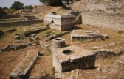
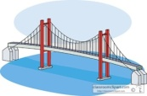
A) B) C) D)

