Mehmet Soysaraç Ortaokulu ………………. Eğitim-Öğretim Yılı 8.Sınıf İngilizce Dersi
2.Dönem 1.Yazılı Sınavı

Adı - Soyadı: Sınıfı / No: NOTU:

A. Complete the sentences with the words. ( 5 x 6 = 30 )
ancient / climate / attractions / structure / population / traditional
1 . Hagia Sophia is in İstanbul, Turkey, and it’s one of the most popular tourist …………………… in the world.
2. I would rather see the Great Wall of China because it is a historic …………………… .
3. Trabzon has a warm and rainy …………… whole year. It has lots of forests and mountains with many rivers.
4. Its …………………… is 758,237 and has an area of 4,664 km.
5. Safranbolu has also delicious …………………… dishes. You should definitely try Kuyu kebab.
6. Göbeklitepe is an …………………… city in southeastern Turkey. Its history goes back about 12000 years.

B. Match the adventure sports with the pictures. ( 5 x 8 = 40 )
1 . go rafting 2. climb a mountain 3. fly in a hot-air balloon 4 . go scuba diving
5 . go caving 6 . do bungee jumping 7 . go on a jeep safari 8 . join a motorcycle tour

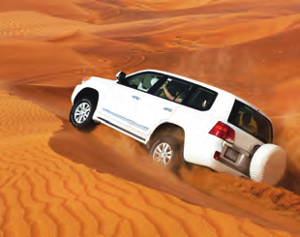

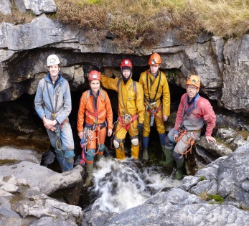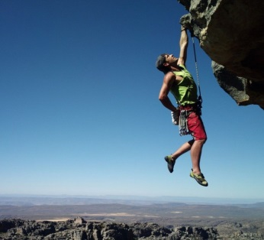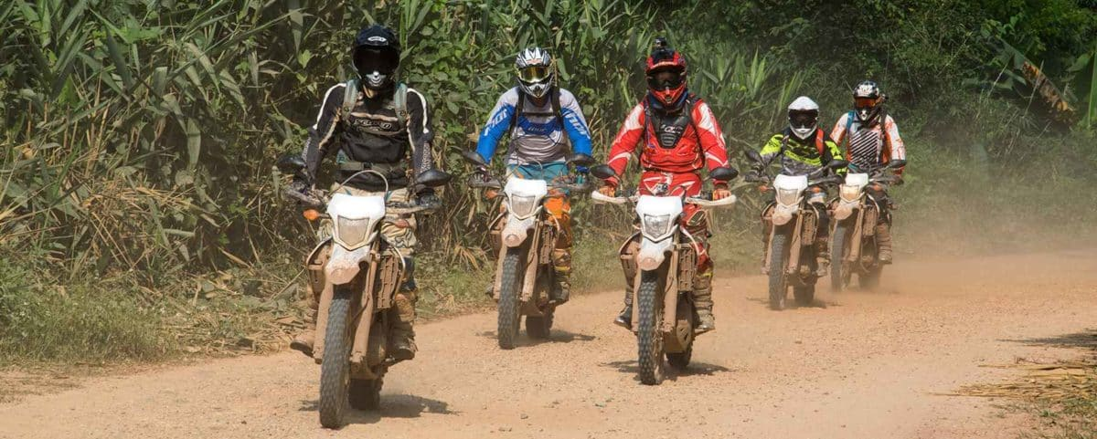

C. Choose the best options. ( 5 x 6 = 30 )

1. My close friend, Marie is an honest girl. She never

tells lies and she keeps my secrets, so I - - - -.

  - can always count on her
  - want to find a new friend
  - don’t get on well with her
  - think she is not a true friend

2. Paul : We are planning to go bowling in the

afternoon. Would you like to join us?
Joseph : Sure, it sounds great. - - - -?
Paul : At about three o’clock.

  - Where is the cinema
  - Who will you go with
  - What are you going to do
  - What time are you going to meet

3. Fiona : Hey, Gilbert! What type of music do you

prefer?
Gilbert : Jazz music is my favorite because - - - -.

  - I can’t stand it
  - that’s not trendy
  - it is really exciting
  - it has unbearable songs

4. Peter : Robert is having a party tonight. Let’s go

together.
David : Sorry, but I’m too busy. - - - -.
Peter : Oh! I can help you.
David : Thanks a lot.

- I’m going to the concert
- I’ll meet with my friends
- I’m watching a sci-fi movie
- I have to finish my school Project

Answer the questions (4-5) according to the passage below.
Hello friends! There are lots of ice cream recipes. I really like preparing ice cream with chocolate sauce. It’s also easy to make at home. Would you like to learn my special ice cream recipe? Then, here it comes for you!
-First, chop some chocolate into pieces.
-Then, mix it with some milk.
-After that, heat it and stir it until it turns into a liquid.
-Finally, put some sugar in and put it on the ice cream.
I hope you all will enjoy it!

5. Betty writes about - - - -.

A) how to make the ice cream
B) the process of the chocolate
C) her favorite cooking blog
D) a cooking magazine

6. Betty - - - -.

A) doesn’t like chocolate sauce
B) prefers eating ice cream in a café
C) loves making his ice cream with fruit
D) thinks it’s not difficult to prepare her recipe

