2. Match the words with
…………… EDUCATION YEAR ATATÜRK SECONDARY SCHOOL
8th GRADE 2nd TERM 1st ENGLISH EXAMINATION

NAME: CLASS:
1. Match the words with the pictures. (8*3=24)
- Read the text and write True and False. (7*3=21)
John : There are lots of things to do in Cairo. I think you should start with visiting the citadel and exploring the Pyramids of Giza. Then, you should go shopping at Khan Al-Khalili, go for a walk in Zamalek, and spend time in Islamic Cairo.
Mike: Sydney is an excellent place to have an enjoyable holiday, because you spend a lot of time on the beach. You can go on a boat trip, sail under the Harbour Bridge, visit the Opera House and see a lot of kangaroos.
Doris: Antalya is a marvellous place to see the sun, sand and history together. You can see Aspendos Theatre there and stay at a five-star all-inclusive hotel by the sea. It is really relaxing and fun.
- Mike prefers going shopping. __
- Mike prefers spending time on the beach. __
- John has visited the citadel in Cairo. __
- John has stayed at an all-inclusive hotel. __
- Doris had a relaxing holiday. __
- Doris visited the Opera House __
- Doris explored the Pyramids of Giza. __
- Mike experienced water sports. __

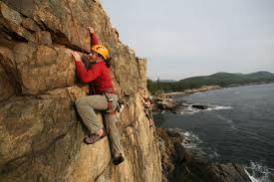
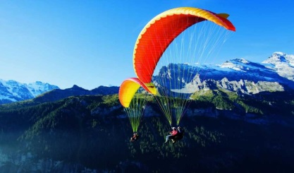
Rock climbing –caving- – skiing–paragliding-hiking– mountain biking- motor racing-parkour running

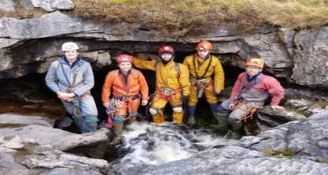
_________________________________________________
_________________________________________________
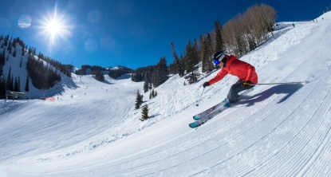
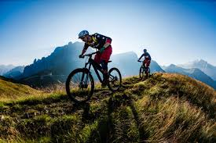
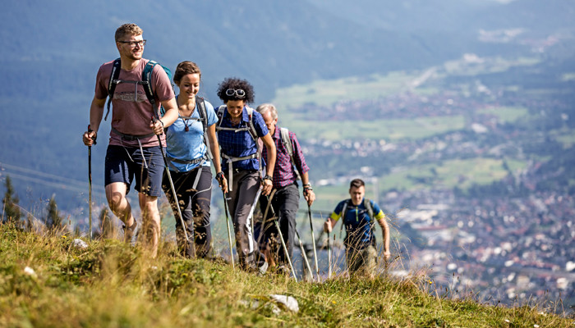

_________________________________________________
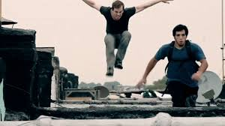
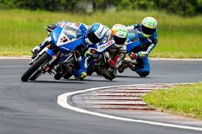

_________________________________________________

4. Fill in the blanks with the comparative form of the Adjectives (5*2=10)
1. İstanbul is --------------------- ------- İzmir. ( crowded ),
2. Mr. Smith is----------------- - ---------Mr. Taylor. ( smart )
3. Hang gliding is ----------------------- caving. ( challenging)
4. Everest mount is --------------- -------Nemrut mount.( high )
5. The Sahara is -------------------- ---------The Gobi. ( large )

3. Fill in the blanks with “prefer” “would rather”. (5*2=10)
1. I _________________________ travelling by bus to travelling by train.
2. John _________________________ walking to running.
3. They _________________________ visit historic sites than modern cities.
4. Jack _________________________ watch TV than going out.
5. She _________________________ going to the cinema to sitting at home.

5. MATCH THE WORDS WITH THEIR MEANINGS. (10*1=10)

1. ancient 6. province a. köy e. el sanatları
2. architecture 7. village b. başkent f. gidilecek yer
3. capital 8. handcrafts c. köfte g. antik
4. destination 9. trade route d. hediye h. mimari
5. gift 10. meatball e. il i. ticaret yolu

6. MATCH THE WORDS WITH THE PICTURES. (5*2=10)
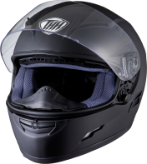
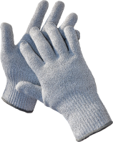


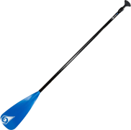
1. HELMET 2. PADDLES 3. GLOVES 4. DROWN
5. COAL MINERS

7. MATCH THE WORDS WITH THE PHRASES? (15*1:15)
Vacuum wash mow load set/ lay sweep clean
take wash mop do Take do take out hang out

_______ the house
_______ the dishes
_______ the floor
_______ the grocery shopping
_______the garbage
_______ the bathroom
_______ the leaves
_______ the clothes

_______ the laundry
_______ the car
_______ the lawn
_______ the dishwasher
_______the table
_______ the dog for a walk
_______ the care of the cat

English Teacher Meryem Çelebi

